# Web 3 Practical – JavaScript regex and canvas

1. Write a JavaScript regular expression that is able to detect both the substrings “color” and “colour” in strings such as "My favorite color is yellow” and "My favorite colour is yellow”. Use the String match method. Use the console.log() method to observe the return value of the match method when the pattern defined in the regular expression is present in the string and when it is not present.
2. Repeat exercise number 1 but this time using the string “My favorite color is yellow. I don't like the colour green”. How can you alter the regular expression definition so that the usage of the match method in the string object returns a match to the 1st and the 2nd instance of the word color/colour?
3. Create a regular expression that searches for a floating-point number (x.x) in the following string: “my height is 1.85 metes”. Using the search method of the string object find the index of the match in the string. What is the value returned by the search method if the string “my height is 2 metes” is provided?
4. Split the string "1,2;3.4-5,6.7" into the array ["1", "2", "3", "4", "5", "6", "7"] using regular expressions.
5. Repeat exercise number 1, but this time use the correct attribute character so you can recognize both instances of the color word in the string: “My favorite color is yellow. I don't like the Colour green”
6. Repeat exercise number 1, but this time use the correct position character to recognize the word color only at the beginning of the string. So for instance the string “color the box” should return a match but the string “box the color” shouldn’t.
7. Write a JavaScript function using regular expressions that finds the substrings “random” in the string “choose a random number“ but fails to find a match in the string “the randomness increased”.
8. Write a JavaScript function that is able to find postal codes in a string containing characters and numbers like for instance “Opoho 9010, Brockville 9011 “. Use those matched numbers later in the code using the $x notation.
9. Write a JavaScript function that using regular expressions checks whether a string input by the user is a valid email address.
10. Write a JavaScript function that draws two rectangles that intersect like the figure shows. Note that one of the rectangles needs to have alpha transparency.

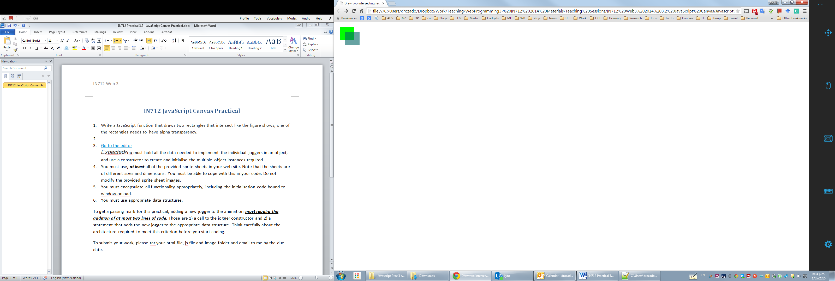

1. Write a JavaScript function that draws the following shape using a canvas path. Make it appear 5 seconds after the page loads.

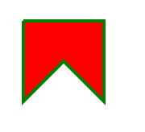

1. Write a script that displays the current date and time (using the javascript Date object) in the provided HTML (inside the div element with id of output). Make it update every second. Hint: use the javascript setInterval global function.
2. Write a JavaScript function that animates a black box to move from left to right:
3. D:\Dropbox\Work\Teaching\IN712 - Web Programming 3\difficultyIcon.pngCreate an animation of the earth circling around the sun

